1.

SEO stands for Search Engine Optimization. It helps you optimize your websites so that they have better

rankings on Search Engines like Google, Bing, and Yahoo.

The ultimate goal of SEO is to rank higher in search engine results pages for relevant keywords and phrases,

which can increase visibility, traffic, and ultimately revenue for the website.

The importance of SEO -

Meta tags are important for SEO because they provide information to search engines about the content on your

site and can help improve your website's visibility and ranking in search engine results pages.

2.

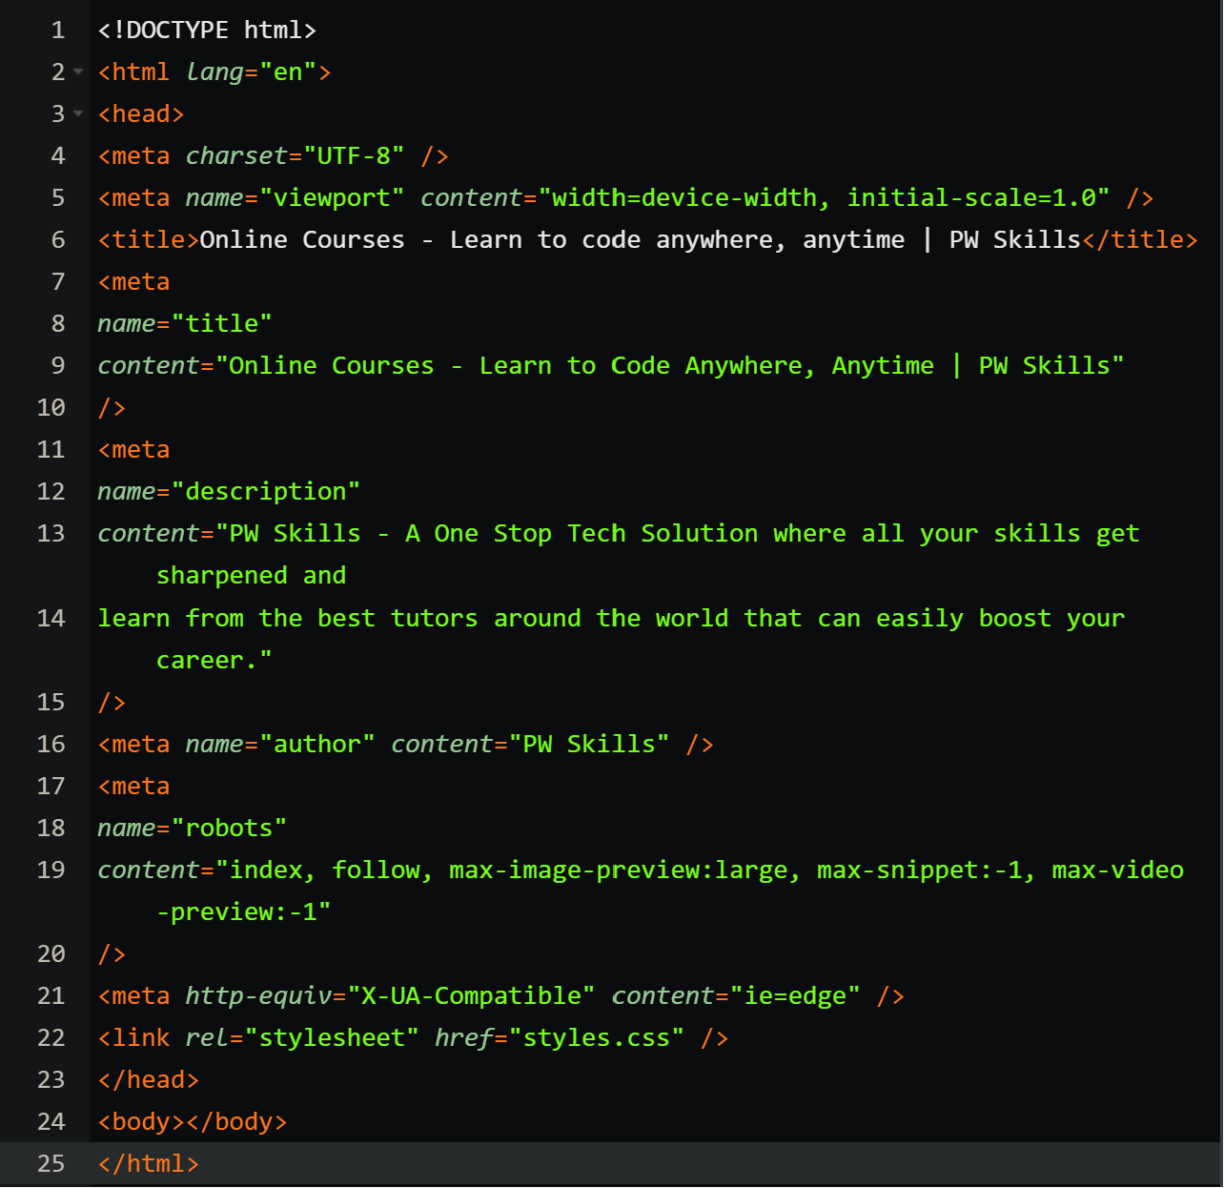

3.

The Benefits of using Meta tags are as follows

**SEO** - (Search Engine Optimization): Meta tags, such as the "description" and "keywords" tags, can help

improve a webpage's visibility on search engine result pages (SERPs).

**Social Media Sharing** - Meta tags like the Open Graph Protocol tags allow developers to control how web

pages are displayed when shared on social media platforms like Facebook, Twitter, and LinkedIn.Z

**Character Encoding and Language** - The meta tag specifying the character encoding (e.g., .TF-8) ensures

that the browser interprets the text correctly, especially when dealing with special characters or multilingual

content.

**Viewport control** - The viewport meta tag is crucial for responsive web design-

**HTTP-Equiv tags** - Meta tags with http-equiv attribute (e.g., <meta http-equiv="refresh">) enable specific

HTTP header functionalities, like refreshing or redirecting the page after a certain time.

4.

<!DOCTYPE html>

<html lang="en">

<head>

<meta charset="UTF-8" />

<meta name="viewport" content="width=device-width, initial-scale=1.0" />

<title>Sample Blog Post - Semantic HTML</title>

</head>

<body>

<header>

<h1>Welcome to the Blog</h1>

<nav>

<ul>

<li><a href="/">Home</a></li>

<li><a href="/about">About</a></li>

<li><a href="/contact">Contact</a></li>

</ul>

</nav>

</header>

<article>

<header>

<h2>How to Create Semantic HTML</h2>

</header>

<section>

<h3>Introduction</h3>

<p>

In this article, we'll explore the benefits of using semantic HTML

elements and how they improve document structure and SEO....

</p>

</section>

</article>

<footer>

<p>&copy; 2023 Your Blog. All rights reserved.</p>

</footer>

</body>

</html>

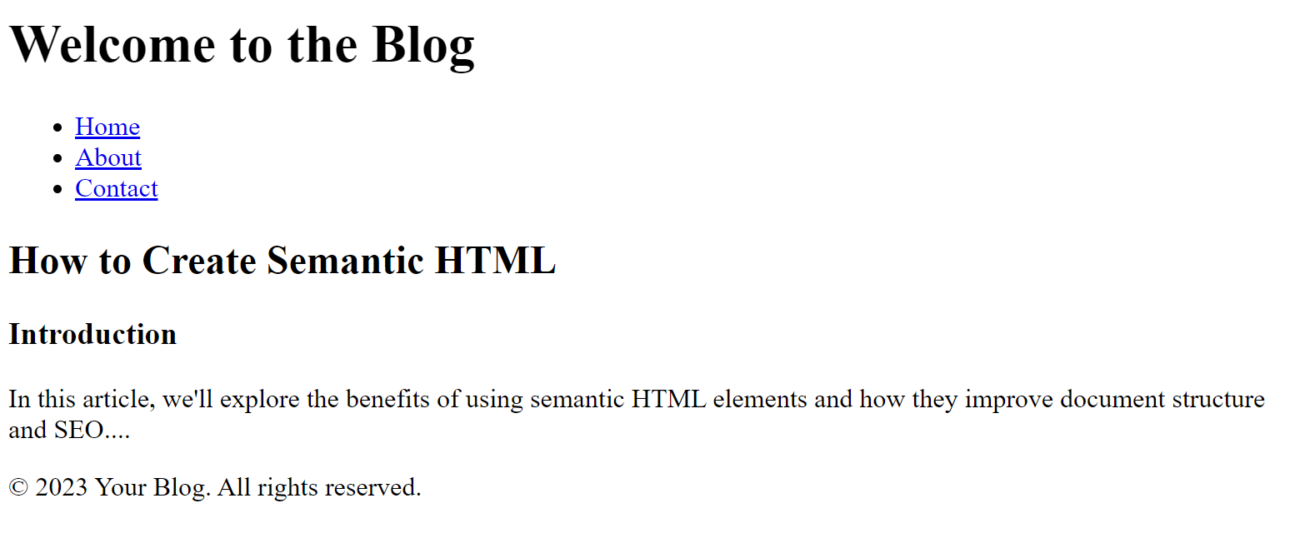

5.

A favicon that stands for a favorite icon is a tiny icon included along with a website, which is displayed in places

like the browser's address bar, page tabs, and bookmarks menu. It is usually 16 * 16 pixels in size and stored in

GIF, PNG, or ICO file format.

They are used to improve user experience and enforce brand consistency. When a familiar icon is seen in the

browser address bar.

**Example –**

